Game Development

IT6034 Project

Endless

**Game Design Document**

Name: Vitor Cazella

Student ID: 91050051

# Game Details

## Name

Endless

## Team

Design, Production and Coding: Vitor Antunes Cazella

## Date of last update

23 September 2020

# Characters and Assets

|  |  |
| --- | --- |
| **Sketch** | **Used** **asset** |
| Spaceship |  |
| Shoot |  |

**Level’s background**

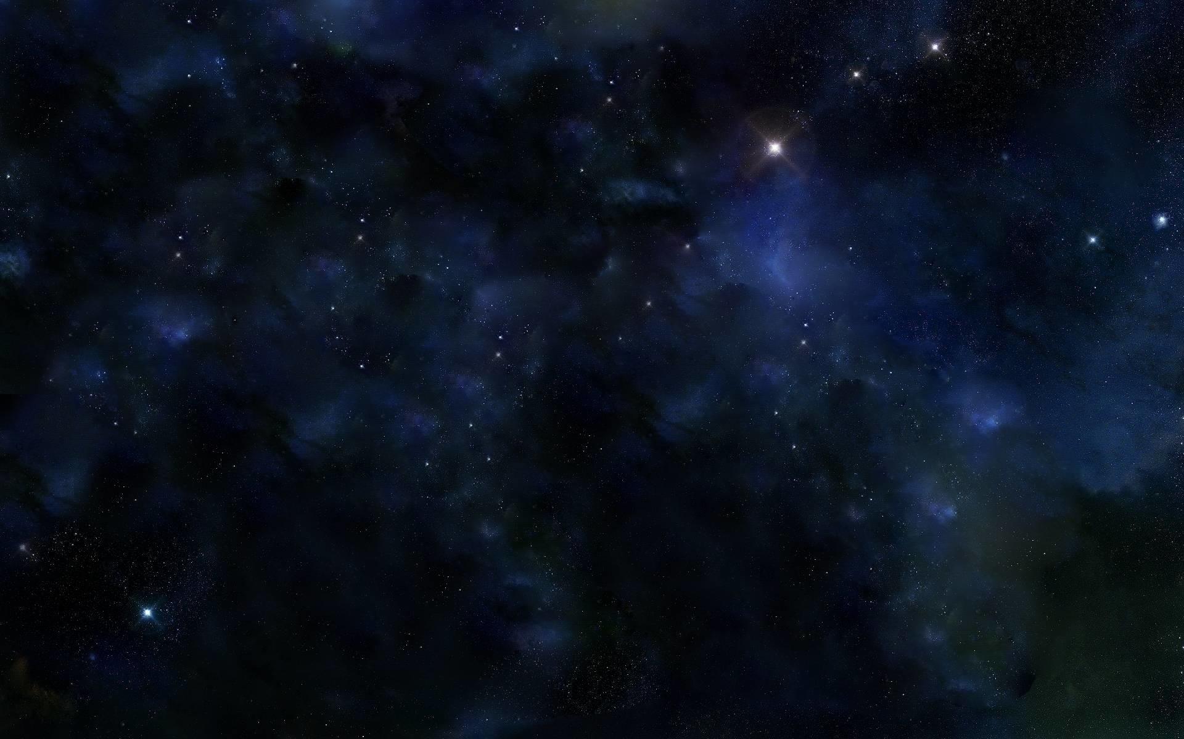 

**Asteroids and others**

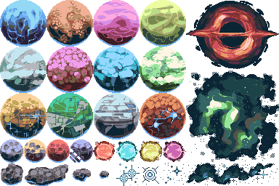

# Game Flow Summary

Start screen

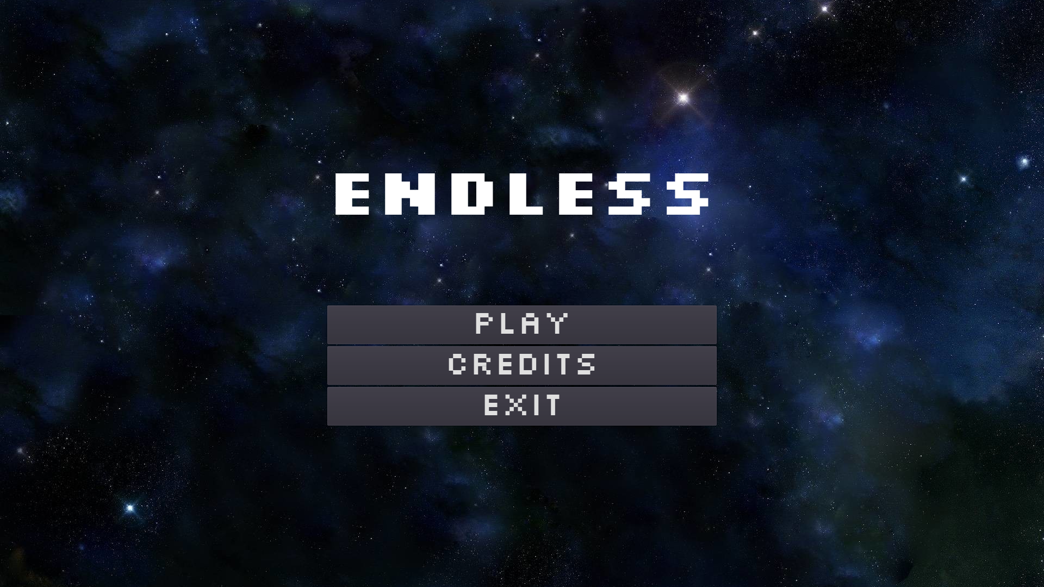

Level 1

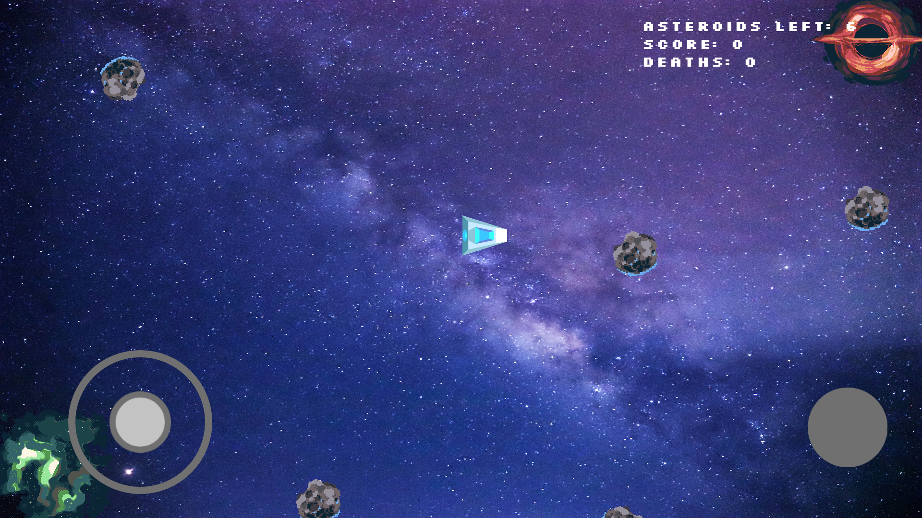

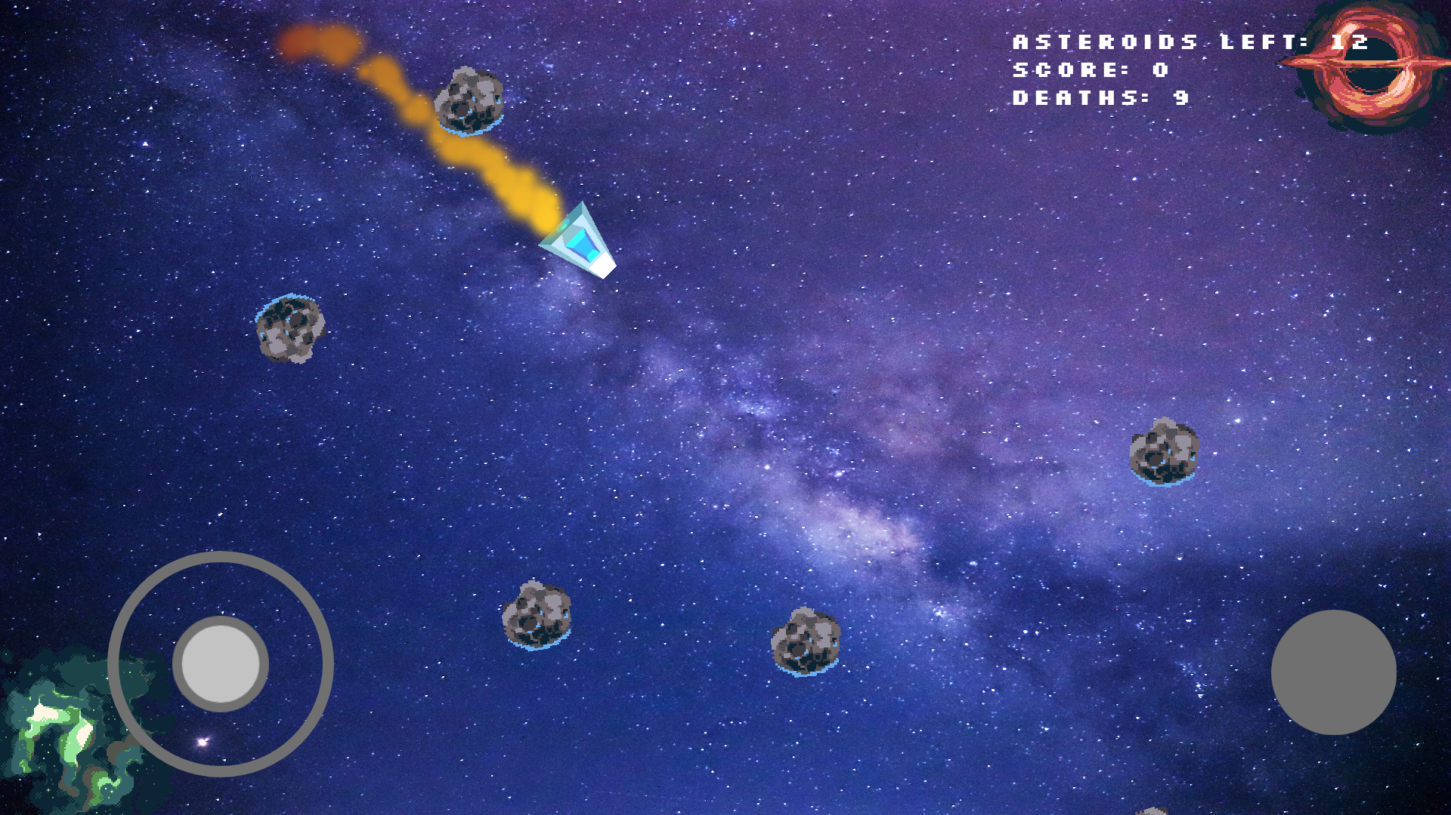

Level 2

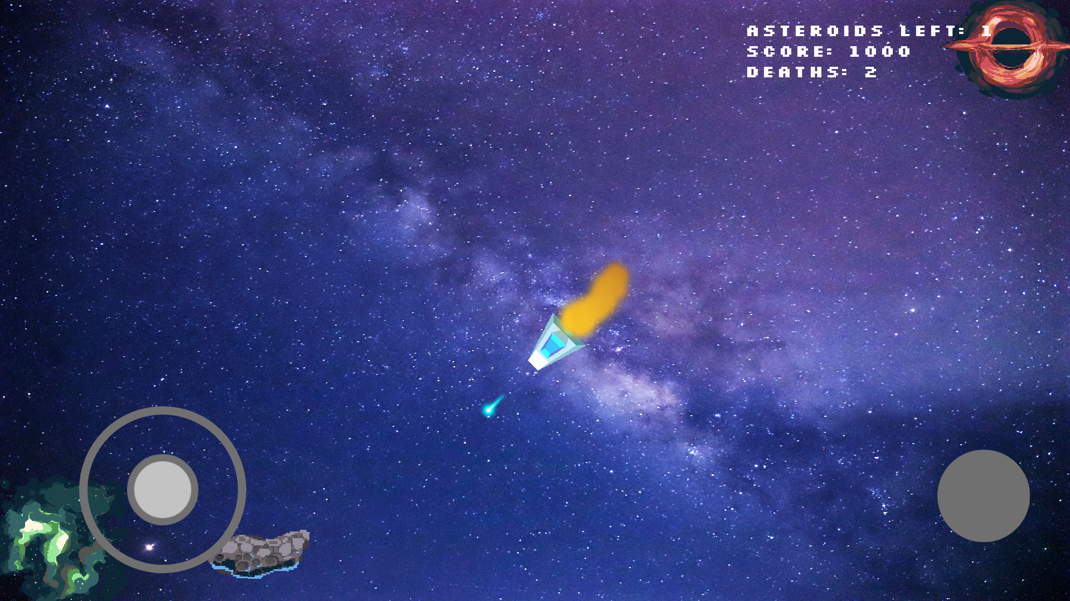

Game Over screen

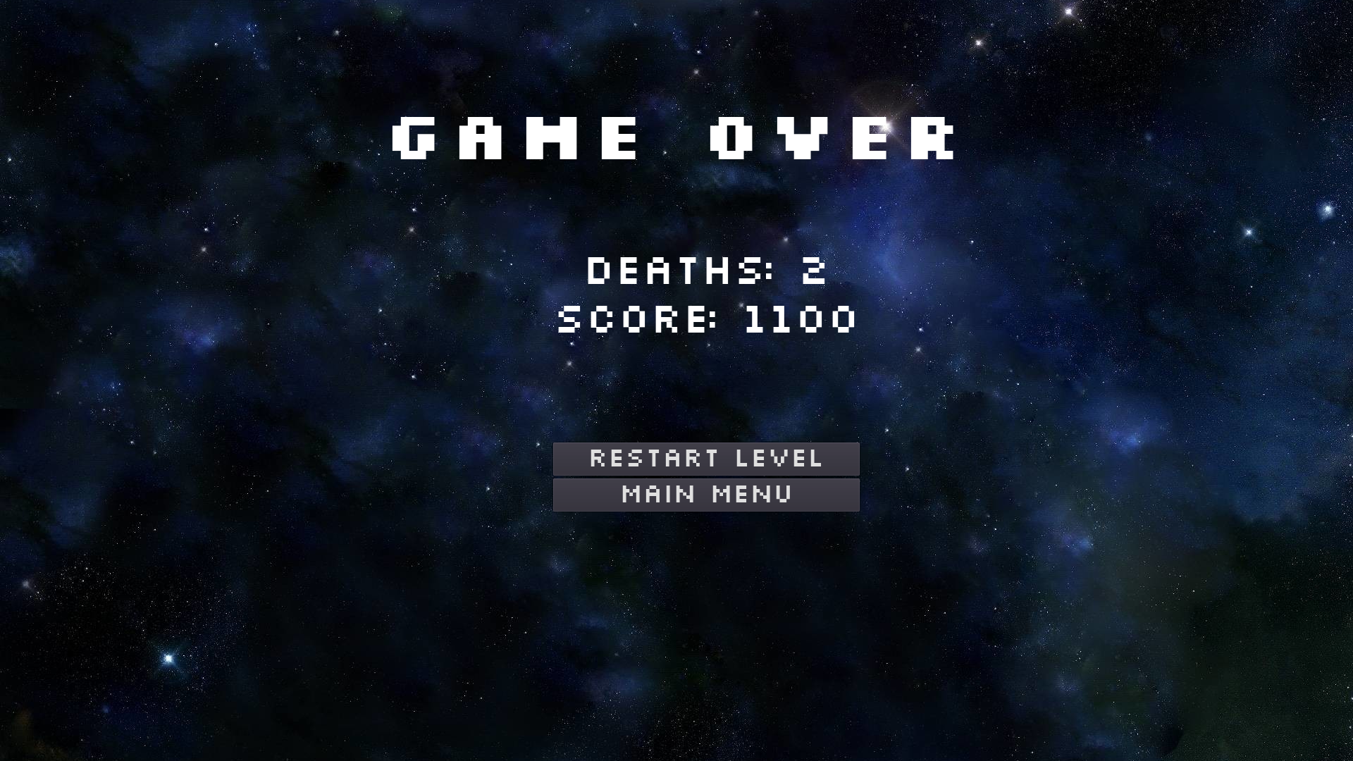

# Development Log (GitHub)

|  |  |  |
| --- | --- | --- |
| **Date of Commit** | **Change** | **Description** |
| Tue Sep 1 13:19:44 2020 | Starting project |  |
| Wed Sep 2 13:03:29 2020 | Movement modifications |  |
| Thu Sep 3 13:59:01 2020 | Changed character's design |  |
| Mon Sep 7 13:42:44 2020 | Working on the bullets |  |
| Tue Sep 8 12:43:30 2020 | Working on a pause menu |  |
| Thu Sep 10 12:47:06 2020 | Working on the pause system |  |
| Mon Sep 14 13:44:54 2020 | Player particles |  |
| Tue Sep 15 15:37:49 2020 | Joystick |  |
| Wed Sep 16 07:36:21 2020 | Joystick adapted |  |
| Wed Sep 16 14:14:25 2020 | Working on asteroid spawner |  |
| Thu Sep 17 13:58:32 2020 | Working on despawn function |  |
| Sat Sep 19 21:10:57 2020 | Asteroids working with manual path |  |
| Mon Sep 21 07:06:29 2020 | Score ready with asteroids in place |  |
| Mon Sep 21 12:57:58 2020 | Score working and added main screen |  |
| Tue Sep 22 07:46:49 2020 | Menu and game over screen |  |
| Tue Sep 22 12:20:14 2020 | Scenes finished |  |